

MIDDLE EAST TECHNICAL UNIVERSITY DEPARTMENT OF ELECTRICAL & ELECTRONICS ENGINEERING

EE 463- Hardware Project – 2025 Fall Simulation Report
DC Motor Drive

Partners:
Ali Tarık Birsoy – 2574796
Metin Özdemir – 2575819
Basri Kaan Demirkoparan- 2442903

TABLE OF CONTENTS
Contents
TABLE OF CONTENTS 2
INTRODUCTION 2
TOPOLOGY SELECTION 3
Main Power Stage: Full Bridge Rectifier 3
DC-DC Motor Drive: H-Bridge 3
Auxiliary Power: Centre-Tap Rectifier 4
Gate Driving & Control: Microcontroller & Bootstrap Gate Driver 4
SIMULATIONS 5
1) Single Phase Full Bridge Diode Rectifier: 5
2) H-bridge: 8
3) Centre-Tap Rectifier: 16
COMPONENT SELECTION 18
REFERENCES 23

INTRODUCTION

In this project, we are making a DC motor starter circuit. We will implement a design for the given adjustable 1 phase AC grid and output of adjustable DC with Vout,max = 180V. The design specifications are given in the Github repository of the hardware project.

We investigated the possible topologies that we might implement. We decided based on our calculations and other parameters like feasibility, easiness to implement and cost. Throughout this report, we will investigate the topology selection in this report and analysis of the simulations. Based on the analysis, we will select our components. We will try to focus on some Bonus Parts as well.

TOPOLOGY SELECTION

Main Power Stage: Full Bridge Rectifier
For the main power bus, a single-phase full-wave diode bridge rectifier topology was selected to convert the 230V/50Hz grid voltage into the DC link voltage.
Advantages:
- It is a simple and robust circuit. It gives 0.9Vs (Vs = 230V) DC output which is highly sufficient for our case.
- Unlike the center tap rectifier mentioned below, it does not require diodes to withstand double the peak input voltage, so we can use diodes with lower withstanding capability, but also lower voltage drop.
Disadvantages:
- Higher Conduction Losses: The current must pass through two diodes simultaneously during each half-cycle. This results in a total voltage drop of approximately 1.4V (typically 2*0.7V), compared to a single diode drop in the center-tap topology. However, at high voltage levels (230V AC), this loss is negligible relative to the output power.
- Non-Linear Loading: This full bridge topology draws current only near the peaks of the AC voltage, resulting in a high crest factor and harmonic distortion (THD) on the AC mains.

DC-DC Motor Drive: H-Bridge
To control the DC motor, an H-Bridge topology consisting of four active switches (MOSFETs) was selected.
Advantages:
- Four-Quadrant Operation: The primary advantage of the H-Bridge is its ability to provide full 4-quadrant control. It can drive the motor in both forward and reverse directions (Motoring quadrants I and III) and actively brake the motor in both directions (Regenerative/Braking quadrants II and IV).
- Controlled Braking: By turning on the two low-side switches simultaneously, the back-EMF of the motor can be shorted (dynamic braking), or energy can be regenerated back into the DC link capacitors.

Disadvantages:
- Control Complexity: The H-Bridge requires a more complex gate drive scheme. The "High-Side" switches (connected to the positive DC bus) require floating gate supplies (bootstrap circuits or isolated DC-DC converters) to operate, unlike a simple Low-Side switch which can be driven directly referenced to ground.
- Shoot-Through Risk: The topology introduces the risk of a "shoot-through" short circuit if the top and bottom switches of the same leg are gated on simultaneously. This requires the implementation of dead-time in the control logic.
- Higher Component Count: It requires four power switches and four diodes, increasing the BOM cost compared to a single-switch buck topology.

Auxiliary Power: Centre-Tap Rectifier
Advantages:
- Lower Diode Drop: The current only passes through one diode at a time (0.7V drop) instead of two in a bridge (1.4V drop). This is more efficient than a full bridge rectifier.
- Fewer Diodes: Less diodes than a full bridge rectifier.
- Buck converter: Very easy to implement (no need to use a discrete buck topology, modules are easy to find and cheap)
Disadvantages:
- Poor Transformer Utilization: We only use half of the secondary winding at any given time. Transformers are also heavier and costlier than a diode rectifier
- Higher Reverse Voltage: The diodes must withstand more voltage in reverse, compared to a bridge rectifier

Gate Driving & Control: Microcontroller & Bootstrap Gate Driver
Control Logic Strategy:
The control stage is responsible for generating the precise timing signals required to operate the H-Bridge. The microcontroller must generate two complementary Pulse Width Modulation (PWM) signals for each leg of the bridge (High-Side and Low-Side).
- Dead-Time Insertion: As noted in the topology selection, simultaneous conduction of the top and bottom switches in the same leg causes a shoot-through short circuit. To prevent this, the microcontroller must insert a “dead-time” (typically 500ns – 1µs) where both switches are OFF before transitioning states.
- ADC Sampling: The microcontroller is also tasked with sampling the DC link voltage and motor current to implement closed-loop control, utilizing the precision reference voltage generated by the auxiliary power stage.
Gate Driver:
Bootstrap Operation Since the H-Bridge utilizes N-Channel MOSFETs for the High-Side switches (connected to the positive DC bus), their gate voltage (V_g) must exceed the DC bus voltage (V_bus) to effectively turn them on (V_gs>V_th). A bootstrap gate driver topology is implemented to achieve this:
- Level Shifting: The microcontroller operates at low voltage logic (3.3V or 5V), whereas the MOSFETs require a higher gate drive voltage (typically 12V-15V) to minimize . The gate driver acts as a level shifter, translating the logic signals into high-power drive signals.
- Bootstrap Charging (Low-Side ON): When the Low-Side switch is ON, the Source of the High-Side MOSFET is pulled to ground. During this interval, the Bootstrap Capacitor () charges from the auxiliary supply () through a Bootstrap Diode ().
- Floating Supply (High-Side ON): When the High-Side switch is commanded ON, the Low-Side turns OFF, and the Source voltage rises to the DC bus level. The diode becomes reverse-biased, and acts as a floating voltage source, maintaining the necessary relative to the High-Side Source.

The final setup for the gate driving and control will be something like shown in the following figure:

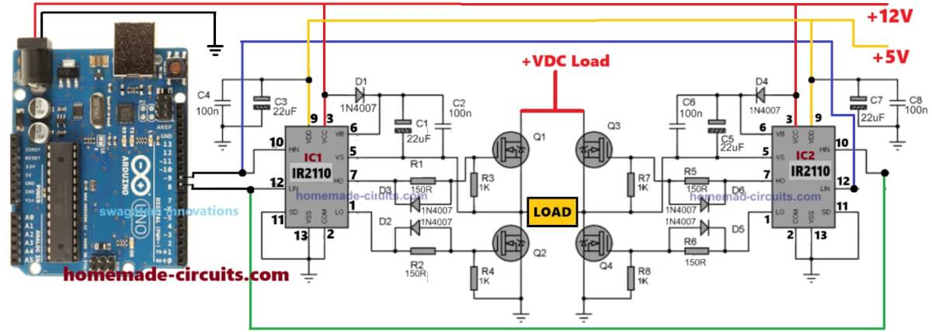

SIMULATIONS

1) Single Phase Full Bridge Diode Rectifier:
Operation Principle: The rectifier operates as a peak detector. When the instantaneous AC input voltage exceeds the voltage across the DC link capacitor, the diodes become forward-biased, conducting current to recharge the capacitor. For the remainder of the cycle, the diodes are reverse-biased, and the capacitor supplies energy to the load, resulting in a slight voltage ripple. We tried to model the circuit as realistic as possible. A small RL branch is added to represent the line impedance. Diodes are modeled based on real products. Capacitor is chosen such that voltage ripple at the output is small.

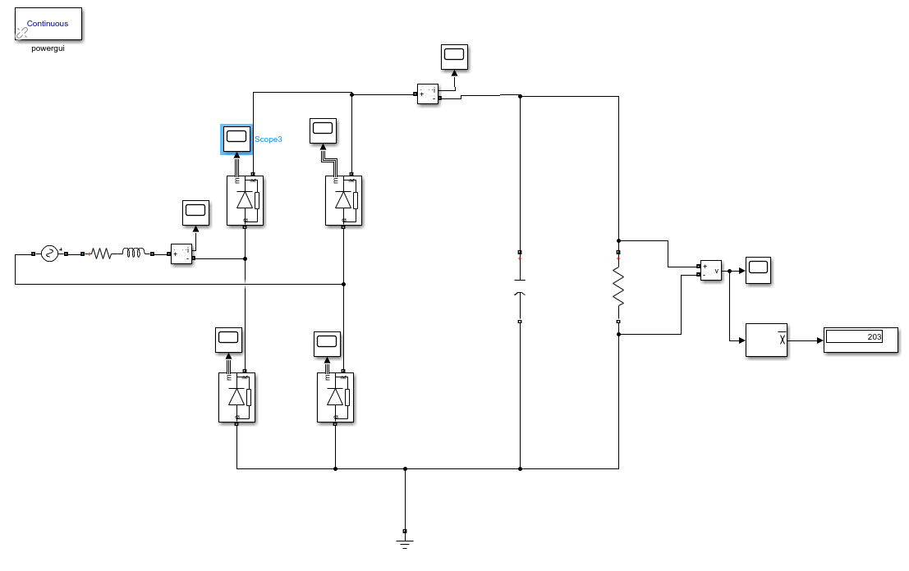
Figure 1: Single Phase Full Bridge Diode Rectifier

In Figure 1, a single-phase full bridge diode rectifier is designed, where diode’s V_{f} is 1.1 V, R_{ON} is 0.036 Ω, capacitor’s value is 1500 µF, R_{LOAD} is 60 Ω, and line impedance is modeled as 0.1 + j*0.001. Input voltage has 215 V peak value at 50 Hz. Output voltage has approximately 15 V voltage ripple which is 7% of input voltage. In Figures 2, 3, and 4, there are voltage and/or current waveforms are represented.

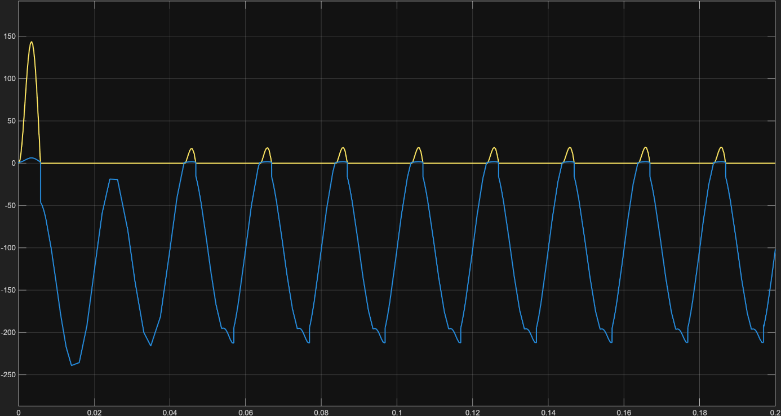
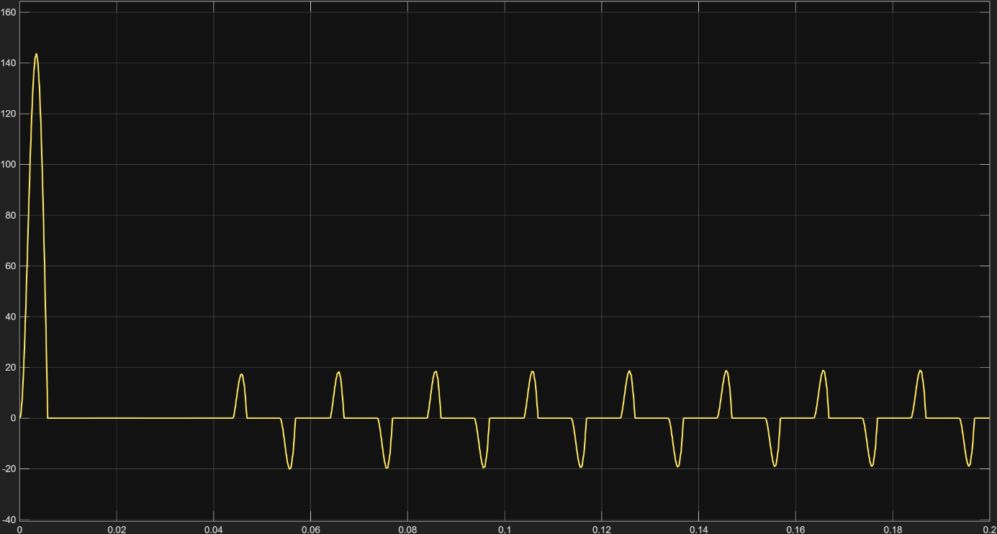
Figure 2: Diode Voltage and Current Waveforms

Figure 3: Input Current Waveform
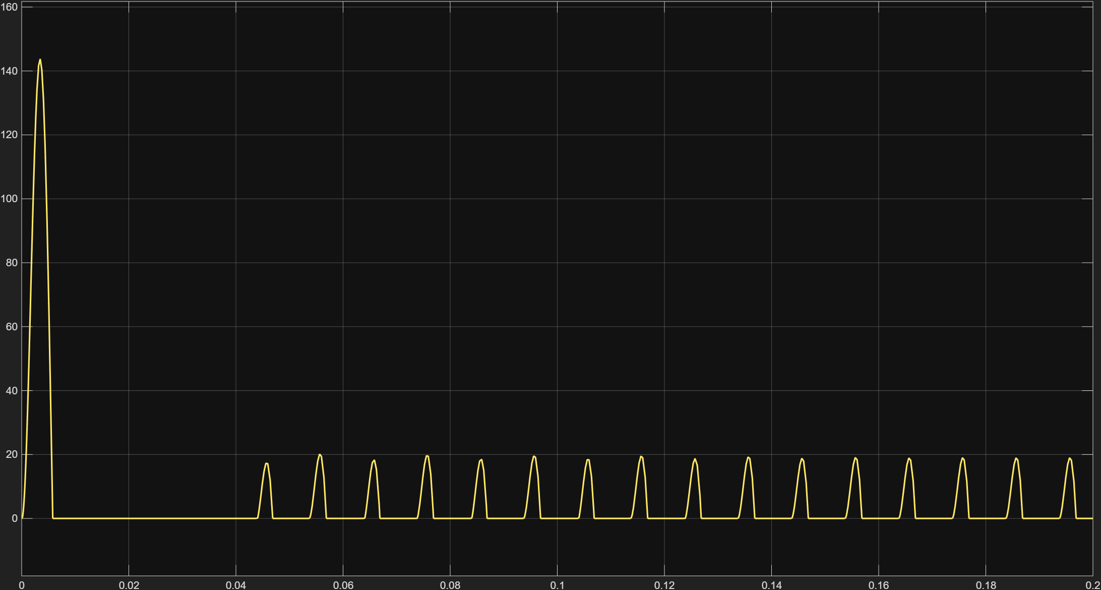
Figure 4: Output Current Waveform
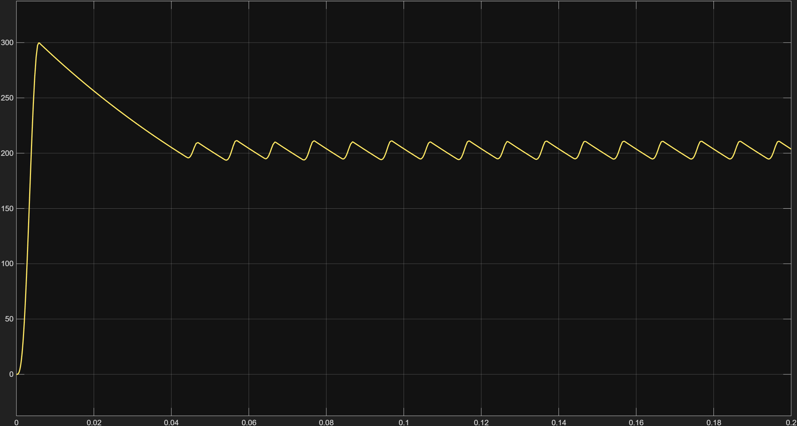
Figure 5: Output Voltage Waveform

2) H-bridge:
The motor drive stage utilizes a full H-Bridge topology consisting of four power MOSFETs (S1, S2, S3, S4) arranged in two legs. The DC Motor is connected between the midpoints of these legs. This topology was selected to enable Four-Quadrant Operation, allowing for potential bidirectional control and regenerative braking capabilities.

Asymmetric unipolar switching used to drive the motor in the forward direction (often called "Slow Decay" mode).
- S4 (Low-Side Right): Held continuously ON. This acts as the "ground anchor" for the circuit.
- S1 (High-Side Left): Switched with a PWM signal. This acts as the "throttle" or voltage chopper.
- S2 & S3: Held OFF. Their internal body diodes remain active to provide protection and freewheeling paths if necessary.
Operation Principle:
The operation cycles between two distinct states based on the PWM signal applied to S1:
- Drive State (PWM = ON):
  - Switches: S1 is ON, S4 is ON.
  - Current Path: Current flows from the DC Bus (+) -> S1 -> Motor -> S4 -> Ground.
  - Voltage: The motor terminals see the full bus voltage (200V). The inductor current rises, storing energy in the motor's magnetic field.
- Freewheeling / Slow Decay State (PWM = OFF):
  - Switches: S1 turns OFF, S4 remains ON.
  - Current Path: The inductance of the motor prevents the current from stopping instantly. The current continues to flow through the Motor, through S4, and recirculates back to the motor input via the Body Diode of S3.
S4 Operation:
S4 is always held in conduction mode during forward motion. Because, when S4 go to blocking mode at the same time with S1, stored current in the motor cannot find a path to flow. Therefore, it uses S2 and 3’s body diodes which implies -200 V across the terminals of the motor. This is called as ‘Fast Decaying’. This cause high ripples at the output, loss of efficiency, and decrease at steady state speed.
To switch between modes, a manual switch logic in Figure 6 has been implied.

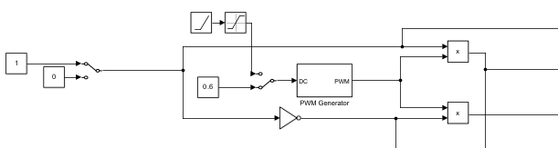
Figure 6: Manuel Switch Logic
First switch controls the forward or reverse drive condition. When the switch is in position 1, a HIGH signal goes to S4’s gate to keep it in conduction mode, and a PWM signal goes to S1’s gate to switch it with PWM. S2 and S3 is in blocking mode during this operation.
There is another manual switch that is used to start with either soft start or without soft start cases.
In Figure 7, there is the H-Bridge circuit with constant dc supply.
In the Figures 8-19 there are voltage and/or current waveforms in no load, load at 20 Nm condition, and constant duty cycle at D=0.6.
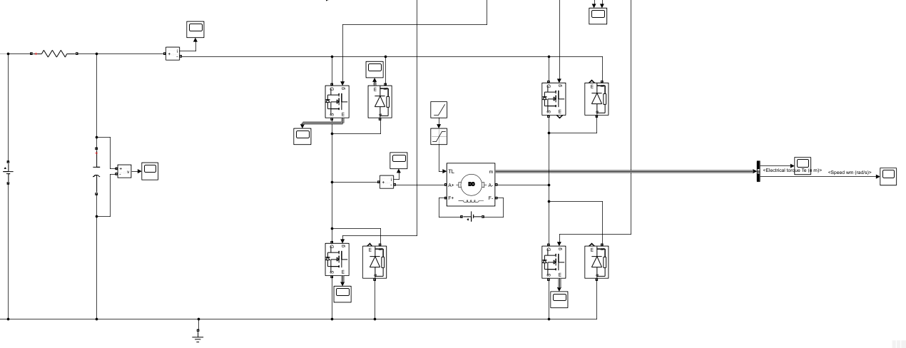

Figure 7: H-bridge Circuit

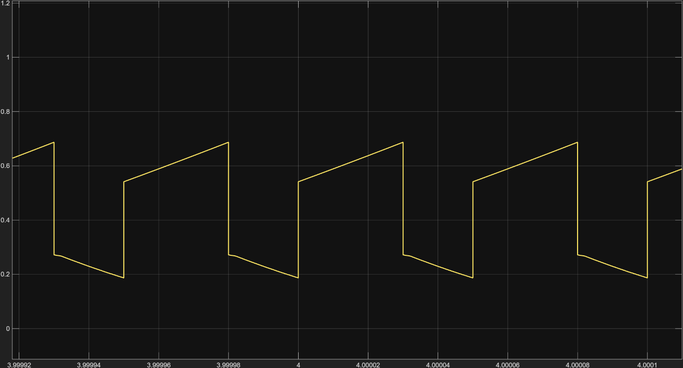
Figure 8: Input Current Waveform at No Load
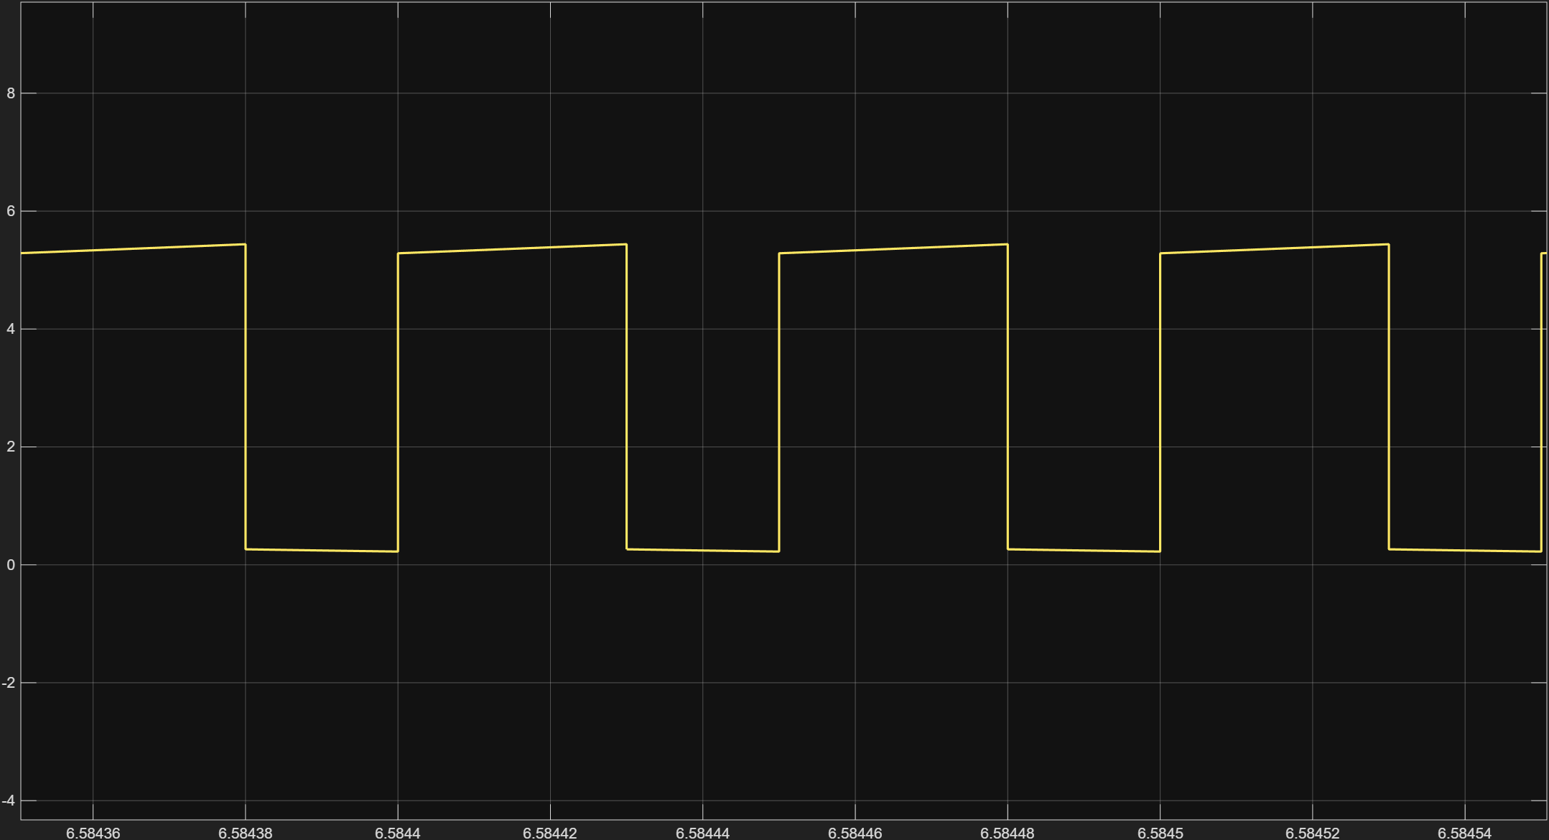
Figure 9: Input Current Waveform at Load Torque is 20 Nm

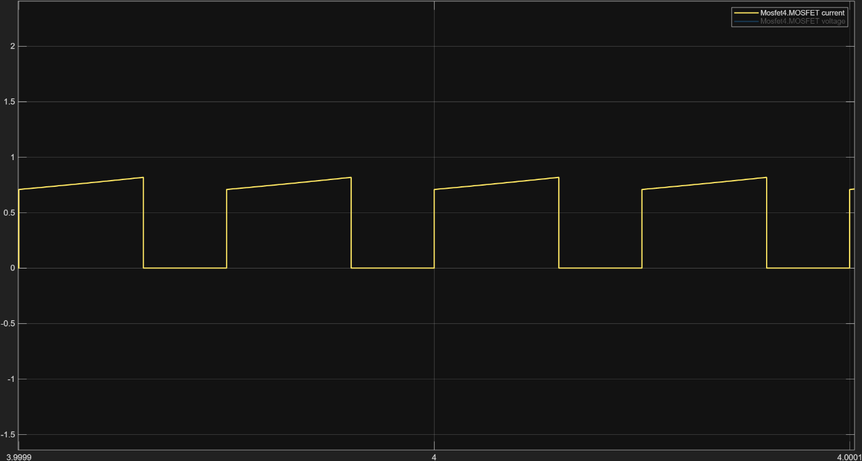
Figure 10: S1 Current Waveform at No Load
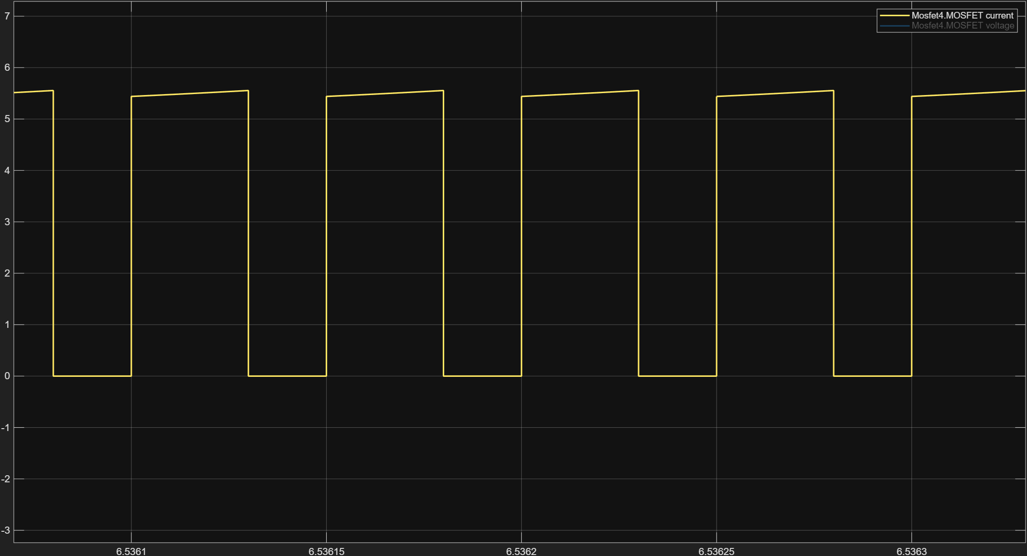
Figure 11: S1 Current Waveform at Load Torque is 20 Nm

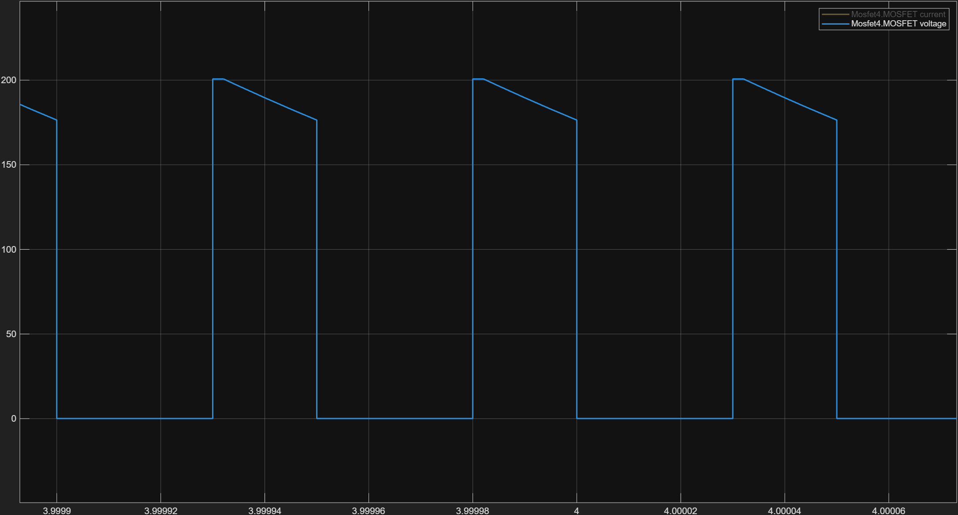
Figure 12: S1 Voltage Waveform at No Load
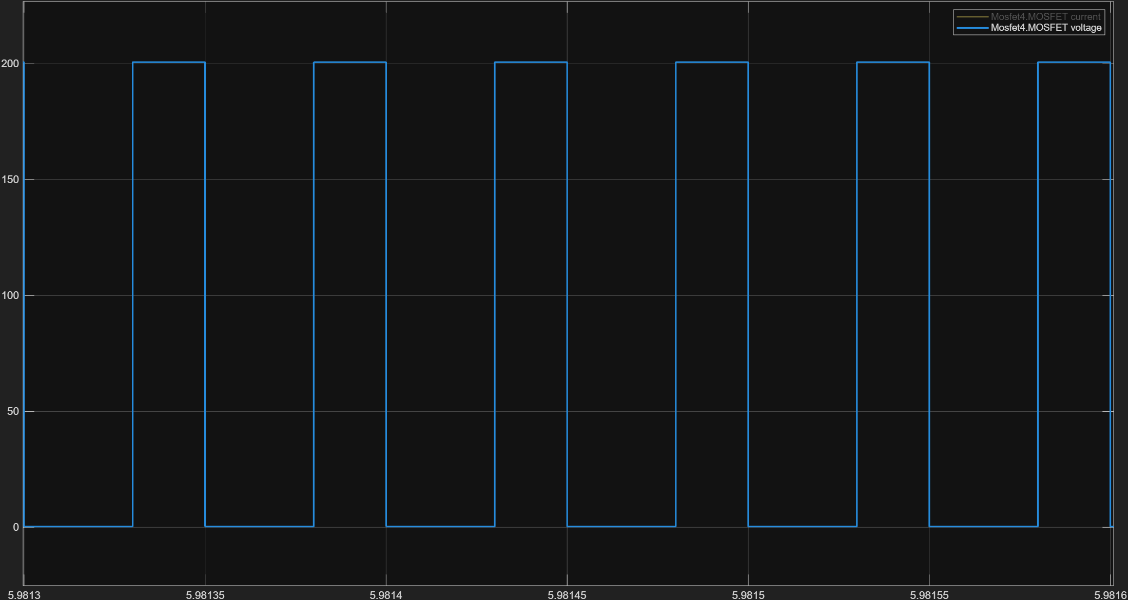
Figure 13: S1 Voltage Waveform at Load Torque is 20 Nm

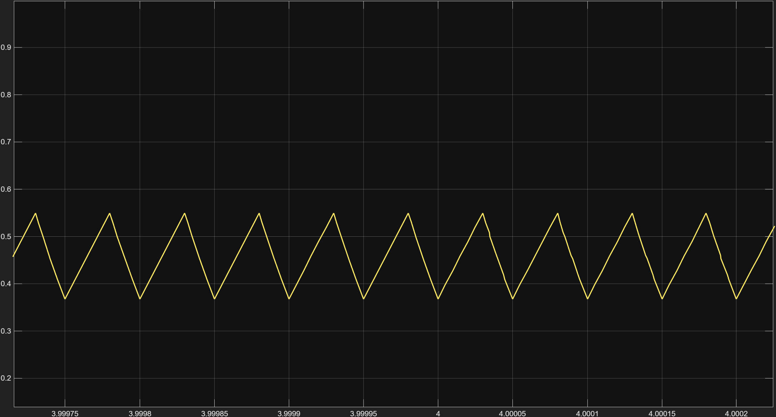
Figure 14: Motor’s Current Waveform at No Load
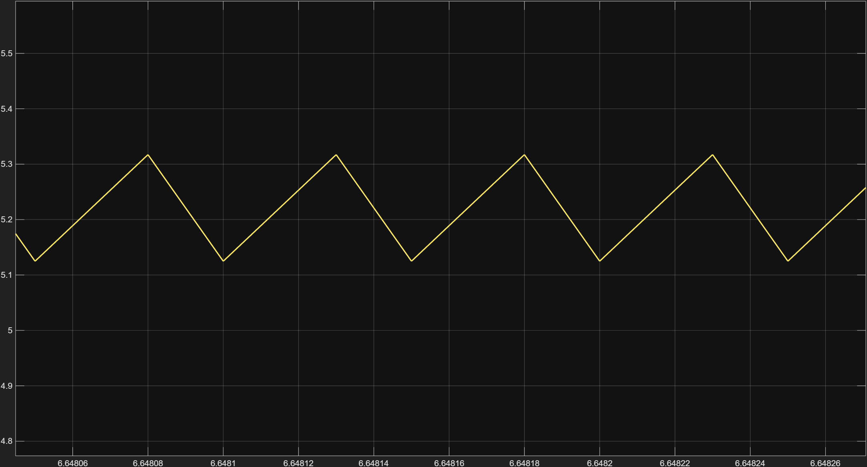
Figure 15: Motor’s Current Waveform at Load Torque is 20 Nm

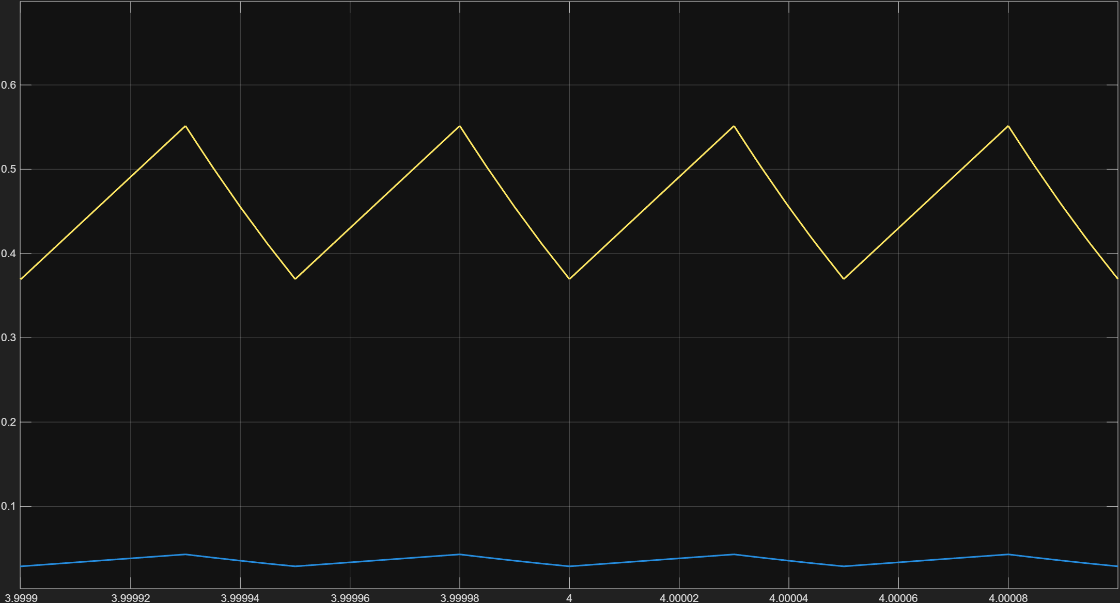
Figure 16: S4’s Voltage and Current Waveform at No Load
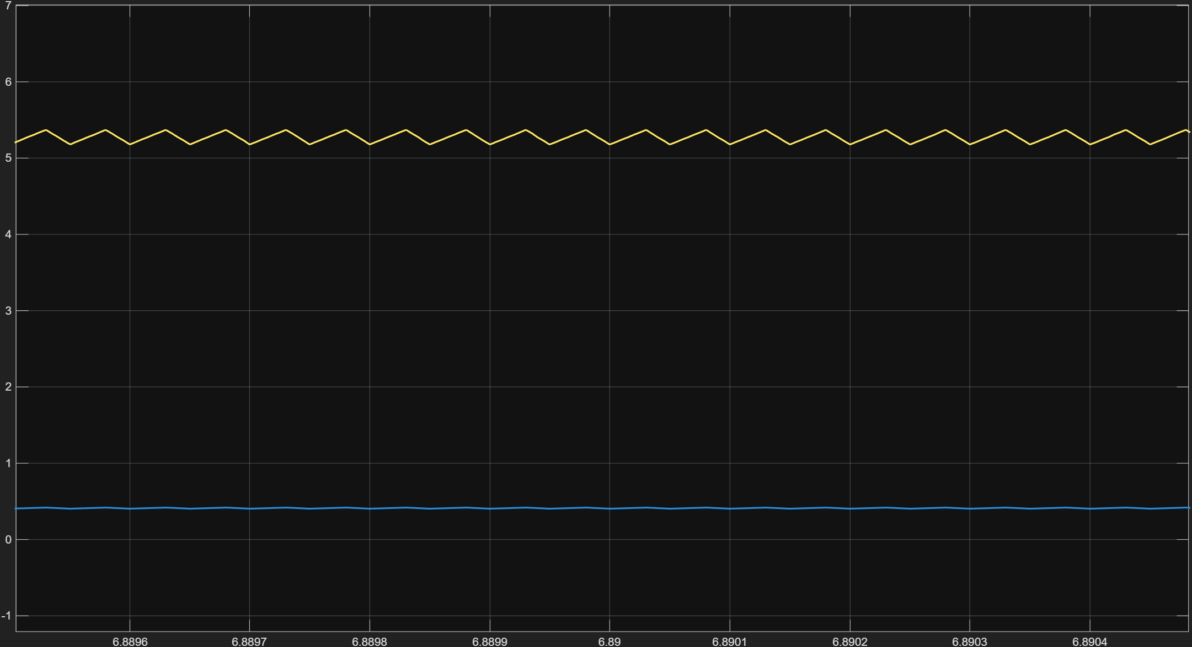
Figure 17: S4’s Voltage and Current Waveform at Load Torque is 20 Nm

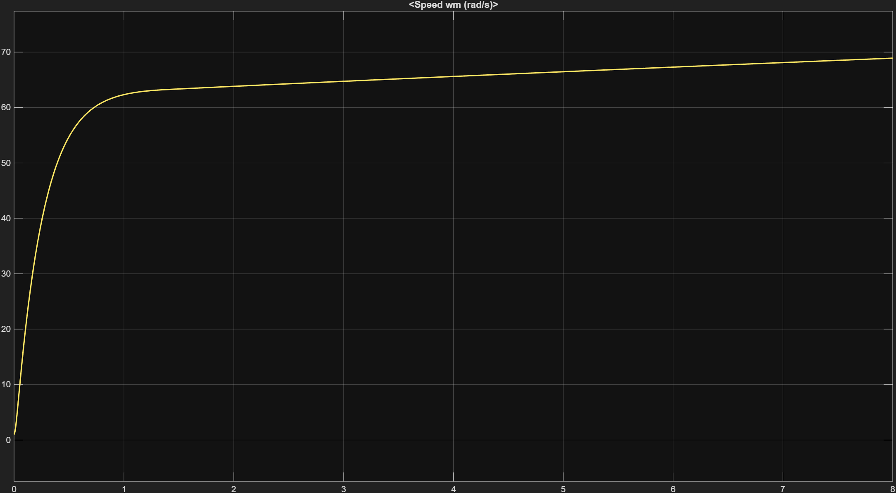
Figure 18: Speed Characteristic of the Motor at No Load
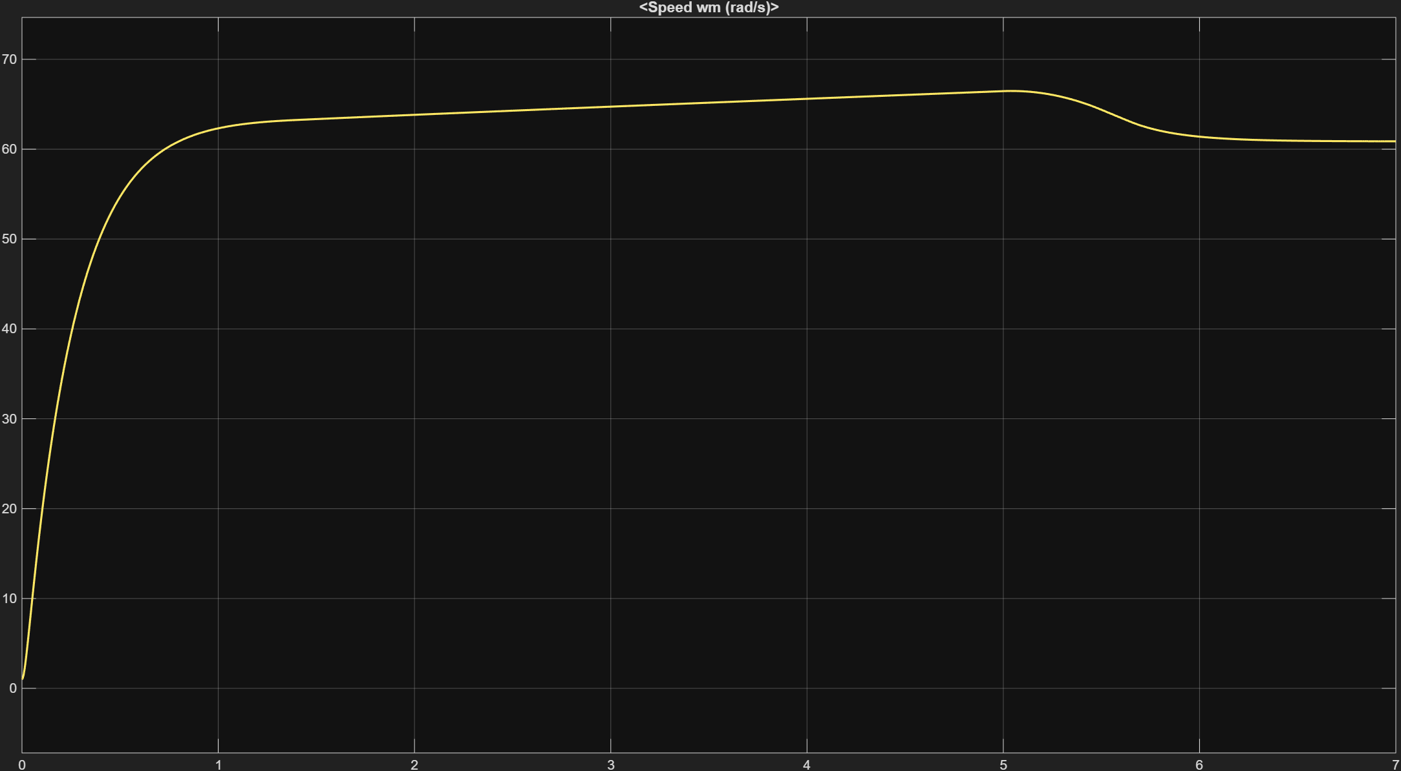
Figure 19: Speed Characteristic of the Motor at Load Torque is 20 Nm

3) Centre-Tap Rectifier:

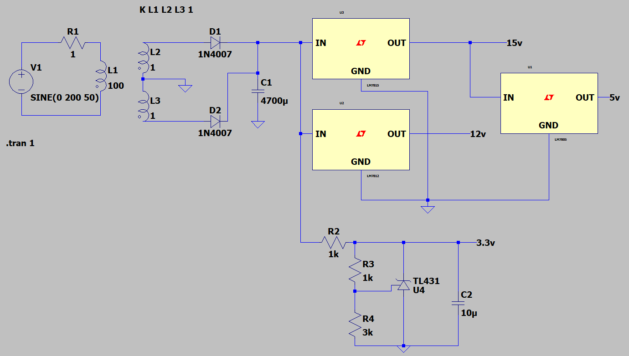
Figure 20: Auxiliary Power Stage Simulation on LTSpice

This part has a simple simulation in which 3 inductors are used to simulate the center-tap transformer and the linear regulators belonging to the LM78xx series are used to generate the necessary voltages. TL431 linear regulator is also simulated as an alternative to the LM78xx series. Both types of regulators work as intended (Figure 22). A large output capacitor is used to smooth out the output voltage coming from the center tap transformer which gives out about 20V DC (Figure 21).
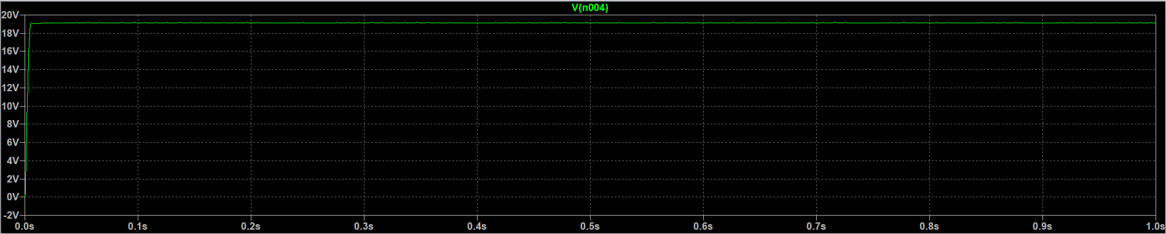
Figure 21: Output voltage of the capacitor

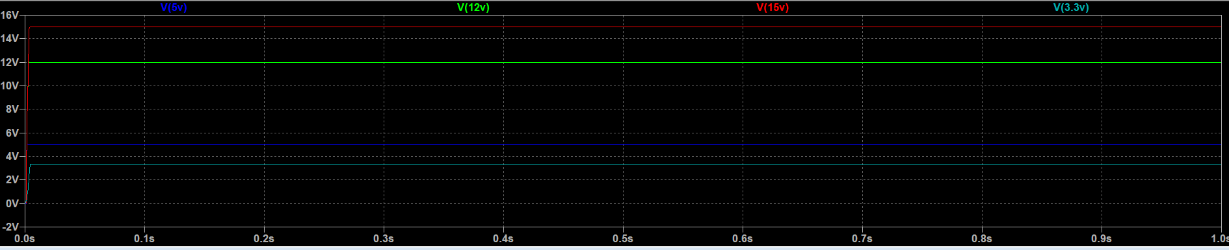 Figure 22: Output values of the regulators

COMPONENT SELECTION
Main Power Stage: H-Bridge MOSFET Selection:
To determine the appropriate switching devices for the H-Bridge topology, we first established the critical operating parameters based on the motor and grid specifications.
Design Requirements:
Voltage Rating: The DC link is generated by rectifying the 230V AC grid, resulting in a theoretical peak voltage of approximately 325V (230V*$\sqrt{2}$). Although the motor is rated 180V, the switches must withstand the full DC bus voltage plus voltage spikes caused by inductive switching. A safety margin of at least 20% over the DC bus is required, but >400V is preferred for reliability.

Current Rating: The system must handle the starting current and dynamic loading of the motor. Also at full load for 2kw tea bonus: I_D> 11A. With a safety margin of 200% to account for inrush currents and thermal derating, a continuous drain current rating of I_D>22A was set as the threshold.

Switching Characteristics: For a switching frequency of 20 kHz, a low Total Gate Charge (Q_g) is desired (preferably <100 nC) to reduce switching losses and gate driver load.

Candidate Comparison:
We evaluated standard legacy MOSFETs against modern Super-Junction MOSFETs:
IRFP250 (Vishay): A standard industry MOSFET, V_DSS = 200V, I_D = 30A
Analysis: While the current rating is sufficient, the breakdown voltage of 200V is critically low for a grid-rectified application. It offers no protection against bus voltage swells or back-EMF spikes.

IRF640N (Infineon): V_DSS = 200V, I_D = 18A
Analysis: This device fails both the voltage safety margin and the current requirement (18A < 22A).

PJMP120N60EC (Panjit): A modern Super-Junction MOSFET. V_DSS = 600V, I_D = 30A, R_DS(on) = 120Ω, Q_g = 42 nC
Analysis: This device offers a massive voltage safety margin (600V vs 325V bus), ensuring the bridge will not fail during braking or grid surges. The gate charge is exceptionally low (42 nC), making it easier to drive at 20 kHz than older planar MOSFETs.
Final Selection:
We selected the Panjit PJMP120N60EC.
It provides the best balance of cost (approx. 63 TL) and performance. The 600V rating allows for robust operation on the Turkish grid (230V), and the 30A rating comfortably handles the motor's starting transients. The low gate charge minimizes the thermal stress on the gate driver IC.

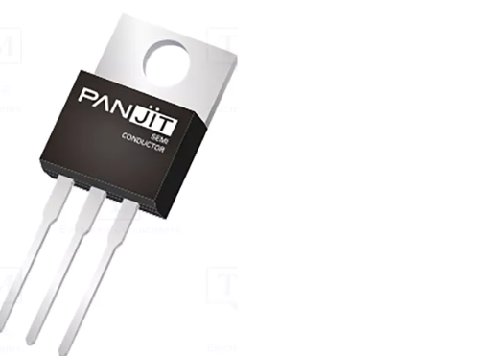
Figure 23. Panjit PJMP120N60EC

Microcontroller Selection:
To implement the control logic described above, the ESP32 was selected.
- Motor Control PWM (MCPWM): Unlike standard microcontrollers, the ESP32 features a dedicated hardware MCPWM unit. This hardware module automatically handles the generation of complementary carrier signals and the insertion of dead-time, significantly improving reliability compared to software-bit-banged solutions.
- Logic Compatibility: The ESP32 operates at 3.3V logic. This is directly compatible with the 3.3V precision reference generated by the TL431 in the auxiliary power stage, ensuring accurate Analog-to-Digital conversions for current sensing.
- Processing Power: The dual-core 240 MHz architecture allows the device to handle high-frequency control loops (20 kHz) on one core while managing safety checks or communications on the second core.

Gate Driver Selection:
Since the H-Bridge topology utilizes N-Channel MOSFETs on the "High Side" (connected to the positive DC bus), a specialized driver with bootstrap capability is required to generate the gate voltage (V_GS) relative to the floating source node.

Requirements:
- Topology: Floating High-Side and Low-Side driver.
- Voltage Offset: Must withstand the 325V DC bus voltage.
- Drive Current: Must supply enough peak current to charge the MOSFET gate capacitance (Q_g = 42nC) within a small fraction of the switching period (20 kHz).
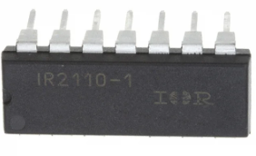
Figure 24. Infineon IR2110

Final Selection:

We selected the Infineon IR2110.
- High Voltage Capability: Operates with offsets up to 500V, covering our 325V bus requirement.
- Output Current: It sources/sinks up to 2A, which is sufficient to switch the selected PJMP120N60EC efficiently.
- Logic Compatibility: The inputs are compatible with standard 3.3V/5V logic from our microcontroller.
- The IR2110 features a separate logic supply pin ($V_{DD}$). By connecting this to 3.3V, it interfaces directly with the ESP32 without requiring external level-shifting transistors.
- The driver can source 2A. Based on the selected Panjit PJMP120N60EC MOSFET, which has a total gate charge ($Q_{g}$) of 42 nC:

$$t_{on}=\frac{Q_{g}}{I_{source}}=\frac{42nC}{2A}=21ns$$

- This fast-switching speed ensures minimal switching losses at 20 kHz.
- The IR2110 can withstand floating offsets up to 500V, providing a safe margin over the 325V DC bus.
- Bootstrap Component Sizing:
  - The external bootstrap components were selected to ensure the High-Side MOSFET gate remains charged during the ON-state.
  - Bootstrap Capacitor ($C_{boot}$): Calculated based on the MOSFET gate charge ($Q_{g}=42nC$) and an allowable voltage ripple ():
$$C_{boot}≥\frac{Q_{g}}{ΔV}=\frac{42nC}{1V}=42nF$$
  - Selection: A 10 µF Electrolytic capacitor was selected for bulk storage, placed in parallel with a 100 nF Ceramic capacitor to handle high-frequency transients.
  - Bootstrap Diode ($D_{boot}$): Selection: UF4007 (Ultra-Fast Recovery Diode). A standard 1N4007 (used in the rectifier stage) is too slow for 20 kHz switching. The UF4007 prevents the charge stored in the capacitor from leaking back into the supply rail when the high-side switch floats up to the bus voltage.

Auxiliary Power Supply Components:
The control electronics (Gate Drivers, Microcontroller, Sensors) require isolated, stable low-voltage DC rails. We implemented a linear supply topology using a center-tap transformer.
Transformer:
We selected the Aslan ASL130101.
- Input: 230V / 50Hz.
- Output: 2x20V (Center Tapped).
- Reasoning: This transformer provides galvanic isolation from the mains. The 20V output provides ample "headroom" (dropout voltage) for the linear regulators to maintain stable 15V and 5V outputs even if the grid voltage sags.
Voltage Regulation:
To manage thermal dissipation efficiently, a cascaded topology was selected. The rectified 20V DC bus is first regulated to 15V using the LM7815.
By powering the LM7805 from the 15V rail rather than the 20V bus, the voltage drop across the 5V regulator is reduced from 15V to 10V. This significantly lowers the thermal stress on the component powering the microcontroller.
- LM78xx Series: Used for the main fixed rails.
  - LM7815: Provides the 15V required for the Gate Driver (V_GS drive voltage).
  - LM7805: Provides the 5V logic supply for the microcontroller.
- TL431 (Precision Shunt Regulator):
  - Used to generate the precision 3.3V reference required for the ADC sensors and specific logic levels. TL431 is used strictly as a precision voltage reference for the ADC, not as a power supply rail.
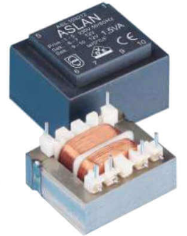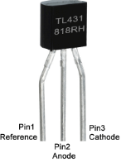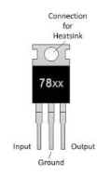
Figure 25. ASL130101 Figure 26. TL431 Figure 27. LM78xx

REFERENCES
[1] Analog | Embedded processing | Semiconductor company | TI.com. (n.d.). https://www.ti.com/
[2] Electronic Components Distributor - Mouser Electronics Turkey. (n.d.). Mouser Electronics Turkey.
https://www.mouser.com.tr/
[3] Özdisan - Do your shopping | Buy cheap components. (n.d.). ozdisan.com. https://ozdisan.com/

